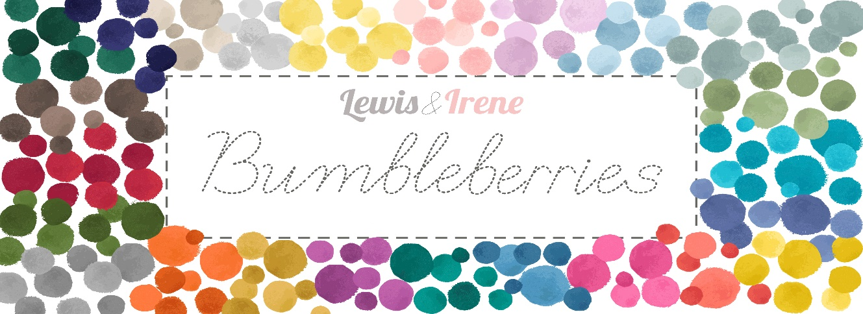
Designed and made by Sally Ablett - Quilt 1
Size of runner 53" x 60" - unfinished block size 8½" x 8½"
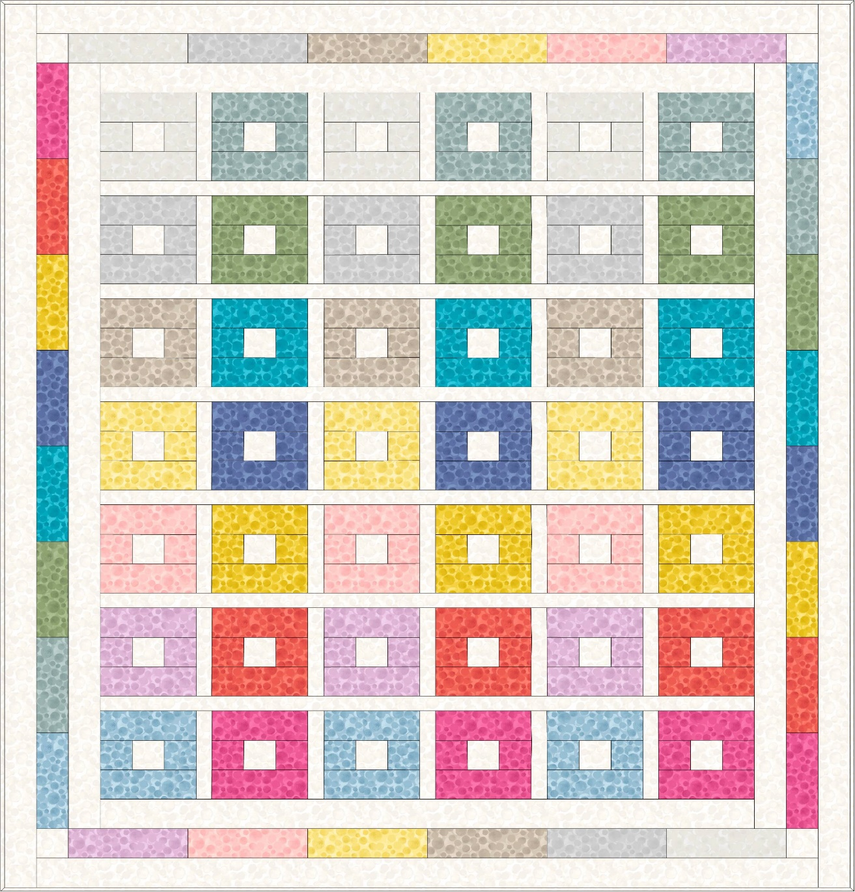
Main Diagram
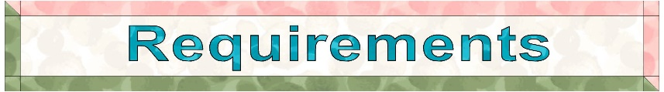
Fabrics from the Bumbleberries collection

- BB01 - White - 2yds - 2m
- BB02 - Cream - fat ¼
- BB03 - Light grey - fat ¼
- BB04 - Latte - fat ¼
- BB05 - Lemon - fat ¼
- BB06 - Light pink - fat ¼
- BB07 - Light lavender - fat ¼
- BB08 - Zennor blue - fat ¼
- BB09 - Studland seafoam - fat ¼
- BB010 - Wiltshire green - fat ¼
- BB011 - Chakli blue - fat ¼
- BB012 - St Ives blue - fat ¼
- BB013 - Sunshine yellow - fat ¼
- BB014 - Polynesian coral - fat ¼
- BB015 - Carnival pink - fat ¼
Wadding and backing 57" x 64"

All measurements include ¼" seam allowances; press each seam as you go.
You need to join your fabric to get the length for the border strips.
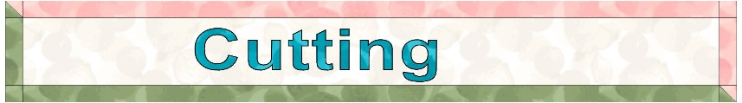

From fabric1 cut

12 x 2½" x WOF
46 x 2½" x 2½" (4 for the corners on middle border)
6 x 1½" x 41½" sashing
35 x 1½" x 6½" sashing

From each of the fabrics 2 to 15 cut

6 x 2½" x 6½"
6 x 2½" x 2½"
2 x 2½" x 8" middle border

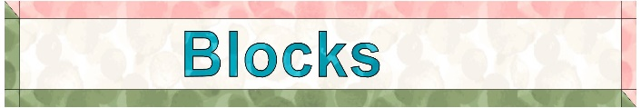

All the blocks are made up in the same way.

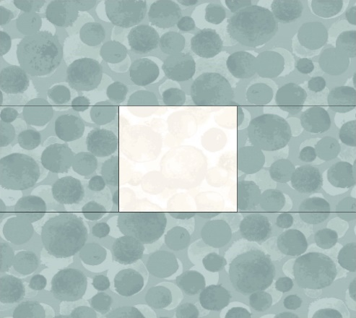 Block diagram.
Lay out the fabric pieces as in the block diagram. Sew the small squares together in the center row.
Then stitch the top strip and bottom to complete the block. You need three of each colour way. 42 blocks in total.

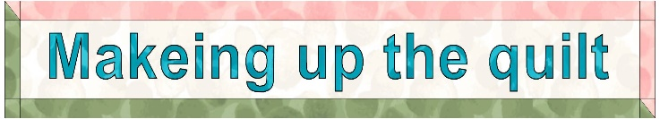

Lay out the blocks and sashing as in the main diagram.
Frist row will be block, sashing and then a block. Work along the row as the main diagram.

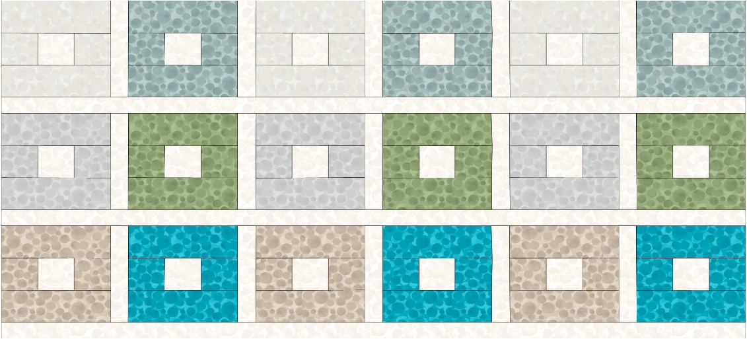
The next row will be a sashing row. Keep working down the rows until
all the blocks and sashing are sewn together to complete the quilt center.

Borders
Inner border - cut
2 x 2½" x 52½" sides
2 x 2½" x 41½" top & bottom

Stitch the top & bottom to the quilt center, press and then the sides.

Middle border
Look at the lay out as in the main diagram for the middle border. Sew the strips together on the short end. On the top & bottom rows add the fabric 1 squares of 2½" x 2½" to each end.
Stitch the sides to the quilt and then the top & bottom.

Outer border
2 x 2½" x 60½" sides
2 x 2½" x 49½" top & bottom

Stitch the top & bottom to the quilt center, press and then the sides.

Sandwich the quilt top, wadding and backing together.
Quilt by hand or machine as desired. Trim the backing and wadding to size of quilt.
Bind quilt with fabric 1.

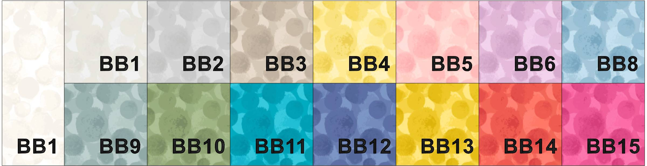

Sally Ablett © 2023

Designed and made by Sally Ablett - Quilt 2
Size of runner 53" x 60" - unfinished block size 8½" x 8½"
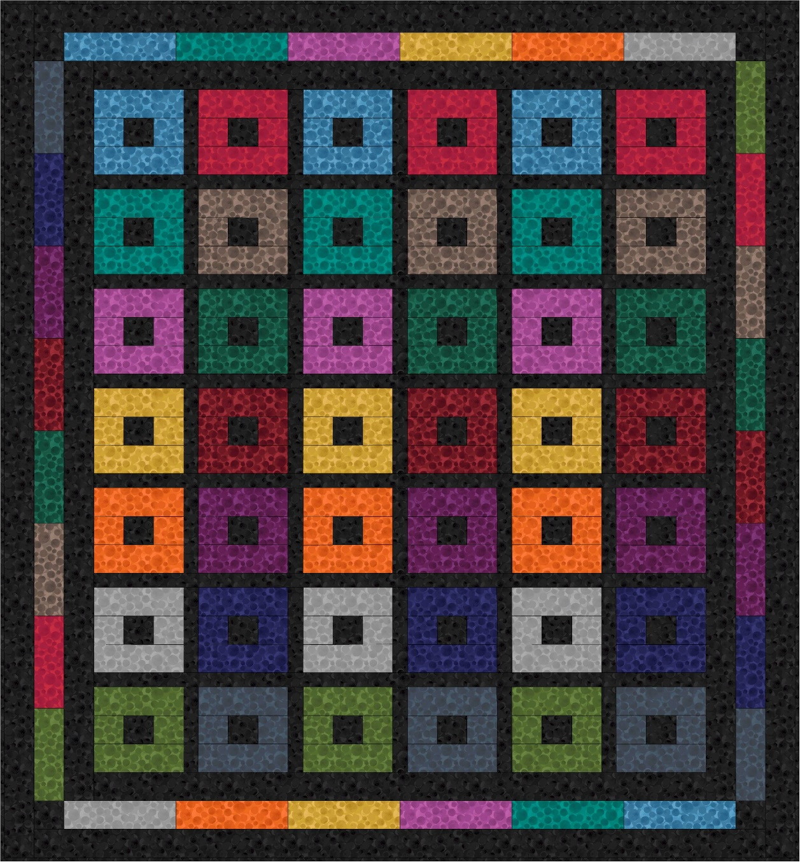
Main Diagram
Fabrics from the Bumbleberries collection

- BB030 - Black - 2yds - 2m
- BB016 - Cornish blue - fat ¼
- BB017 - Hampshire green - fat ¼
- BB018 - Berry purple - fat ¼
- BB019 - English mustard - fat ¼
- BB020 - Brazilian orange - fat ¼
- BB021 - Rock - fat ¼
- BB022 - New Forest green - fat ¼
- BB023 - Post-box red - fat ¼
- BB024 - Chocolate - fat ¼
- BB025 - Nordic green - fat ¼
- BB026 - Dark red - fat ¼
- BB027 - Royal purple - fat ¼
- BB028 - Navy blue - fat ¼
- BB029 - Indigo - fat ¼
Wadding and backing 57" x 64"

All measurements include ¼" seam allowances; press each seam as you go.
You need to join your fabric to get the length for the border strips.

From fabric1 cut

12 x 2½" x WOF
46 x 2½" x 2½" (4 for the corners on middle border)
6 x 1½" x 41½" sashing
35 x 1½" x 6½" sashing

From each of the fabrics 2 to 15 cut

6 x 2½" x 6½"
6 x 2½" x 2½"
2 x 2½" x 8" middle border

All the blocks are made up in the same way.

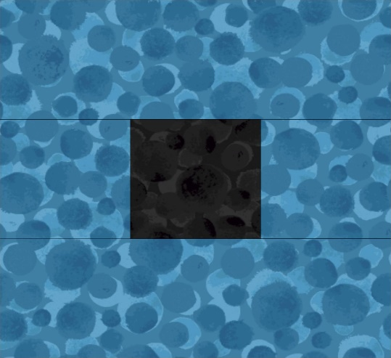 Block diagram.
Lay out the fabric pieces as in the block diagram. Sew the small squares together in the center row.
Then stitch the top strip and bottom to complete the block. You need three of each colour way. 42 blocks in total.

Lay out the blocks and sashing as in the main diagram.
Frist row will be block, sashing and then a block. Work along the row as the main diagram.

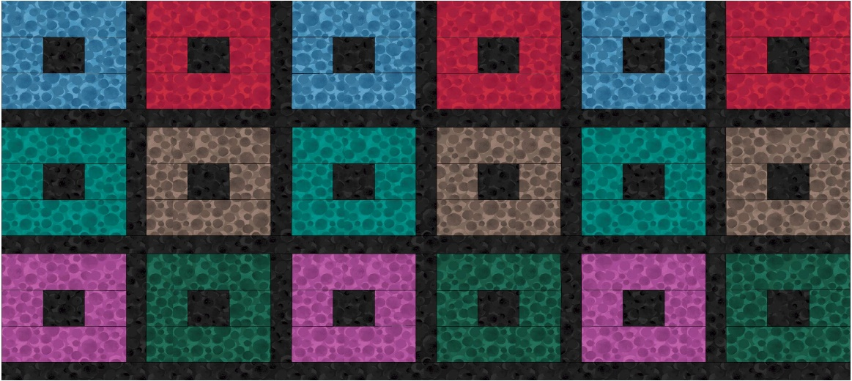
The next row will be a sashing row. Keep working down the rows until
all the blocks and sashing are sewn together to complete the quilt center.

Borders
Inner border - cut
2 x 2½" x 52½" sides
2 x 2½" x 41½" top & bottom

Stitch the top & bottom to the quilt center, press and then the sides.

Middle border
Look at the lay out as in the main diagram for the middle border. Sew the strips together on the short end. On the top & bottom rows add the fabric 1 squares of 2½" x 2½" to each end.
Stitch the sides to the quilt and then the top & bottom.

Outer border
2 x 2½" x 60½" sides
2 x 2½" x 49½" top & bottom

Stitch the top & bottom to the quilt center, press and then the sides.

Sandwich the quilt top, wadding and backing together.
Quilt by hand or machine as desired. Trim the backing and wadding to size of quilt.
Bind quilt with fabric 1.

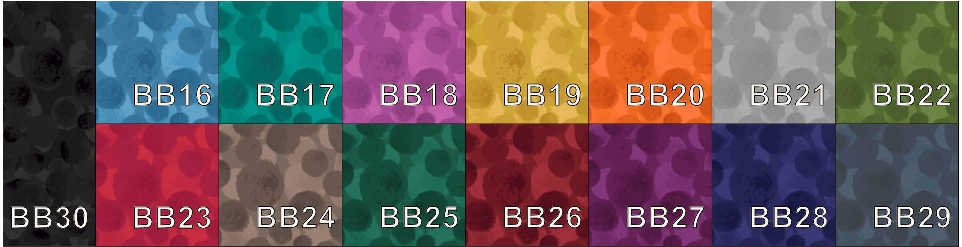

Sally Ablett © 2023

